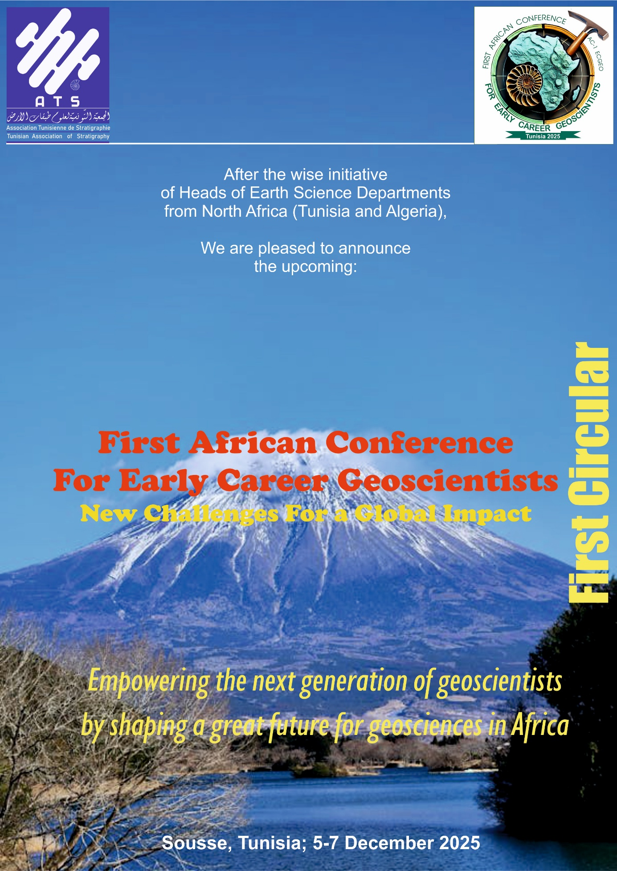



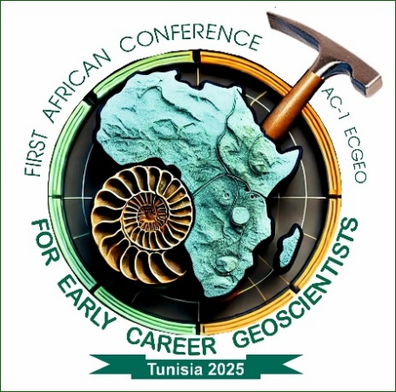

**TABLE OF CONTENTS**

|  |  |  |
| --- | --- | --- |
| 1. | INVITATION | 2 |
| 2. | **STARTING WORDS** | 3 |
| 3. | **CONFERENCE LEADERS** | 4 |
| 5. | **HONORARY GUESTS** | 5 |
| 6. | **ACADEMIC PARTNERS AND NATIONAL DELEGATES** | 6 |
| 7. | **CONFERENCE ACADEMIC COORDINATORS** | 7 |
| 8. | **STEERING COMMITTEE** | 8 |
| 9. | **KEYNOTE TALKS, COURSES AND WORKSHOPS** | 13 |
| 10. | **CONFERENCE VENUE** | 14 |
| 11. | **FIELD TRIPS** | 16 |
| 12. | **REGISTRATION AND ACCOMODATION FEES** | 17 |
| 13. | **AWARDS AND HONORS** | 18 |
| 14. | **PRACTICAL RULES AND FINAL WORDS** | 19 |

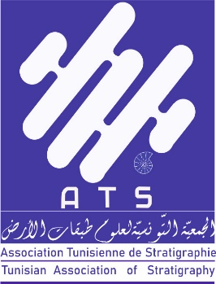

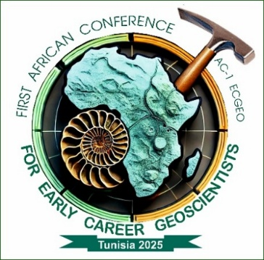

**Conference Leaders**

**starting words**

*Dear Senior and Early Career Geoscientists;*

*Dear colleagues and students from all over Africa,*

*We are pleased to announce the upcoming « First African Conference for Early Career Geoscientists (AC1- ECGEO 2025) », dedicated to fostering collaboration and knowledge exchange among young researchers and senior experts in the various fields of Geology and Earth Sciences. This conference will take place from 5-7 December, 2025 at Sousse (Tunisia).*

*As we face unprecedented challenges on our planet, including climate change, environmental degradation, and the sustainable management of water resources, it is crucial for geologists to unite in addressing these pressing and critical issues. The impacts of climate change are being felt across Africa and at a global scale, affecting ecosystems, agriculture, and water availability. Therefore, it is our responsibility as geoscientists to contribute to solutions that promote sustainability and resilience in our communities.*

*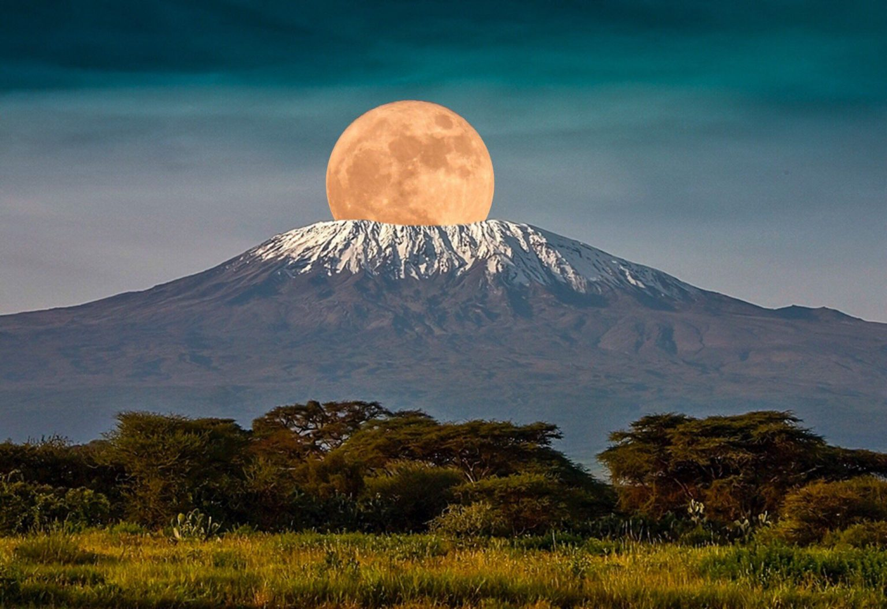This congress will provide a platform for participants to discuss the latest research findings, share innovative ideas, and explore collaborative approaches to tackling these challenges. We will highlight the significant role that new technologies play in addressing geological issues, from remote sensing and data analytics to advanced modeling techniques. These tools are essential for enhancing our understanding of complex geological processes and for developing effective strategies for resource management and environmental protection.*

*This congress will also serve as a platform for discussing the latest research findings and exploring innovative approaches to various fundamental geology and earth sciences disciplines as we will emphasize their substantial contributions to their interdependant applied geology. We will highlight the role of new technologies in advancing our understanding of geological processes. Tools such as remote sensing, data analytics, and advanced modeling techniques are essential for addressing complex challenges and developing effective strategies for sustainability.*

*We strongly encourage young researchers to present their work, participate in workshops designed to enhance their skills and knowledge, and engage with senior experts in discussions that promote collaboration and innovation. Senior researchers are invited to share their expertise and mentor emerging talents, fostering a vibrant academic community dedicated to advancing the wide field of geology and earth sciences.*

*We look forward to your participation in this vital discourse on the future of geology in Africa.*

***O/B the Organizing Committee ;***

***The Conference General Chair :***

***Professor Mabrouk Boughdiri***

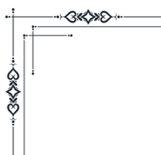

**STARTING WORDS**

***O****rganizing the «African Conference for Early Career Geoscientists (AC1-ECGEO2025)» stems from the rich geological heritage of the continent, which offers a unique opportunity for exploration and discovery. Africa is home to diverse geological resources that are essential for sustainable development and environmental management. By fostering intra-African collaboration, we aim to strengthen networks among emerging researchers, enabling them to share knowledge and expertise across borders. Additionally, it is crucial to empower young scientists by providing them with access to mentorship from experienced professionals in the field. This conference will serve as a platform for learning, collaboration, and innovation, ensuring that the next generation of geoscientists is well-equipped to address the challenges facing our planet.*



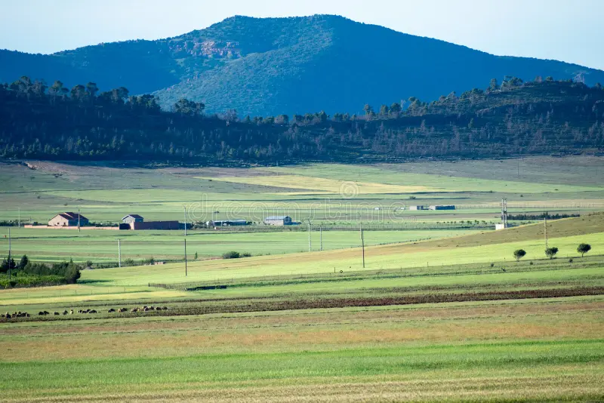*The idea of organizing the first African Conference for Early Career Geoscientists was born out of the success of a Tunisian-Algerian collaboration project. Despite hard field works, the enthusiasm and perseverance of both young researchers and experienced geoscientists allowed the team to overcome challenges and achieve significant scientific results. This collaboration not only fostered excellent relationships within the mixed team but also sparked the idea of extending such partnerships to other research teams in Tunisia and Algeria, and eventually across the Maghreb region. Ultimately, the vision evolved into a desire expressed by many heads of earth sciences departments to bring together all young African geoscientists and their mentors around a large discussion table in the form of the proposed conference. The dream is to see this initiative expand globally, transforming it into an international platform for collaboration and knowledge sharing among emerging geoscientists.*

***The Conference leaders and National Delegates***

